Happy Valley Business School
Department(s): Master of Business Administration
Semester: 03 | Section(s): Finance Specialization
International Trade Finance
Course Instructor(s): Santhosh Raja R
Activity : The Trading Game

Activity Objectives
- simulate trade between countries
- adjust to new world situations as they arise
- reflect on what they learned about trade between countries

Activity Outcomes
- Students will understand the importance and how international trade happen

Activity
1. Divide the class into small groups and set up the game.
Tell students that they will participate in a hypothetical trading game. Divide the class into five groups and assign each group one of the following countries: United Kingdom, China, Colombia, Saudi Arabia, and Ghana. List the following exports and their values on the board for reference during trading:

Gold—5 points per unit
Oil—4 points per unit
Lumber—3 points per unit
Electronics—2 points per unit
Coffee—1 point per unit
Provide each group with a random set of approximately ten trading cards from the handout.

2. Introduce the objectives of the game.
Tell students that the objective is for each student to get the most points by trading their country’s goods for products from another country. Each team will start with a set of trading cards that represents their country’s worth. The game allows for “free trade,” meaning any country can trade with another country, and any item and/or amount of product can be traded for another. Explain to students that they can creatively market their products or combine products to end up with something more desirable.

3. Conduct the first round of trading.
Allow for ten minutes of open trading. Then announce the following:

WORLD SITUATION: The world is running out of oil, making oil extremely rare and much more expensive.
OUTCOME: The worth of oil increases by two points.
Update the point system on the board to reflect the increase in points per unit for oil.

4. Conduct the second round of trading.
Allow for two additional minutes to trade. Announce that trading time is over and have groups tally points.

5. Adjust the results to reflect a new situation.
Offer the following world situation and outcome to see how it impacts the final results:

WORLD SITUATION: Ghana learns to make counterfeit electronics, making its electronics cheaper.
OUTCOME: Ghana takes one electronic unit from each country.
Re-tally the points and figure out who got the most points.

6. Have students reflect on what they learned.
Discuss the following questions:

Did any countries end the game richer or poorer than they started? Which ones?
What was it like to be a rich country? A poor country?
Was it easy or difficult to trade? Why?
Did any countries feel especially powerful or powerless?
Which items were most popular? Which were least popular? Why?

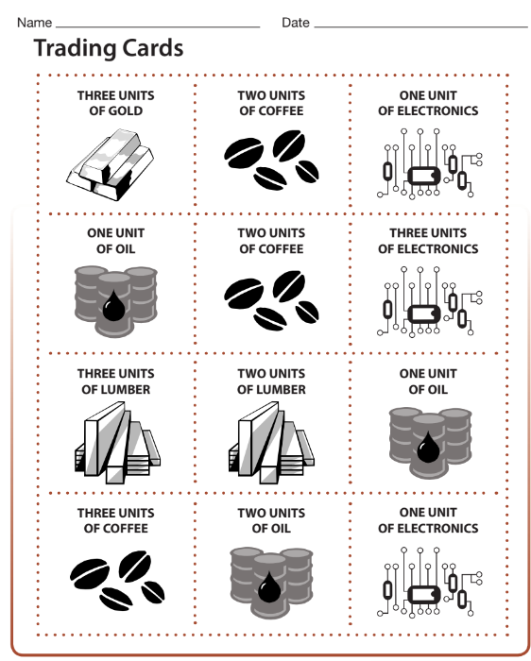

Happy Valley Business School
Department(s): Master of Business Administration
Semester: 03 | Section(s): Finance Specialization
International Financial Management |  | Buying Sheet :
Team Name :
Activity : The Trading Game
Name of the Student’s :

Name of the Country :

Sl.No | Traded Item | Units | Points | Revised Points | Revised Points
Total
Happy Valley Business School
Department(s): Master of Business Administration
Semester: 03 | Section(s): Finance Specialization
International Financial Management |  | Selling Sheet:
Team Name :
Activity : The Trading Game
Name of the Student’s :

Name of the Country :

Sl.No | Traded Item | Units | Points | Revised Points | Revised Points
Total

