Happy Valley Business School
Department(s): Master of Business Administration
Semester: 04 | Section(s):
Brand Management (BA 5001) (Batch: 2020 – 22)
Course Instructor(s): K Sampath Kumar
Activity: Mall Visit – Brookfield’s Mall

Activity Objectives
- To ensure students get to know the concepts through experiential learning
- To make them understand the functioning of retail stores, brands, differentiations, displays, promos etc..,
Activity Outcomes
- Better understanding about different types of brands, mall layout, anchor shops, brand associations….
- Categorization of Brands, layout of mall
- Visual Appeal
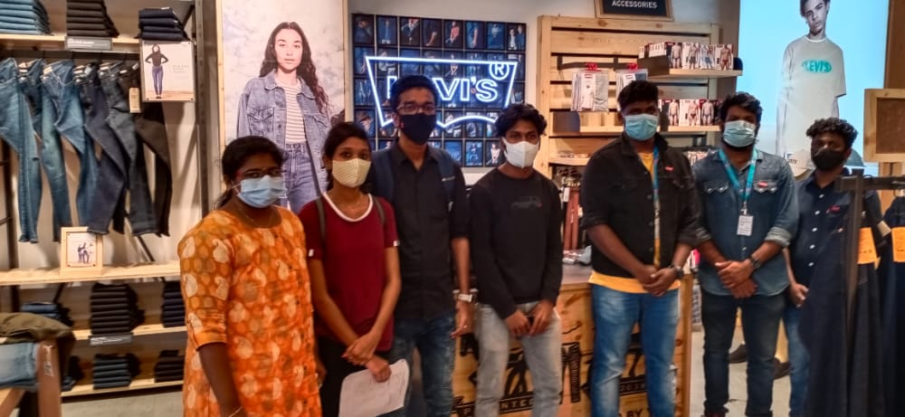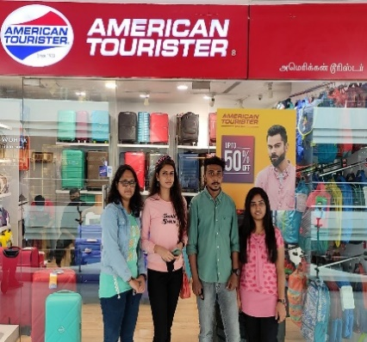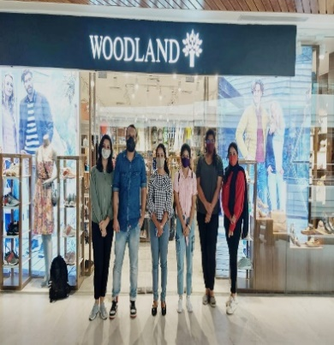
Duration: Mall Visit – Brookfield’s Mall, Coimbatore.
Delivery: Experiential Learning – Observation, Enquiry of facts from store personnel and entry of questionnaire.
Subject Content: Teams are splitted based on the number of sops in the mall. Students go across various shops to obtain the data. (Sample’s of team allotment and questionnaire are given in the picture.

